INTRODUTION
OVERVIEW
- To create a social media for our institution
- Purpose
To reach the students with tha invitation

PROBLEM DEFINITION & DESIGN THINKING
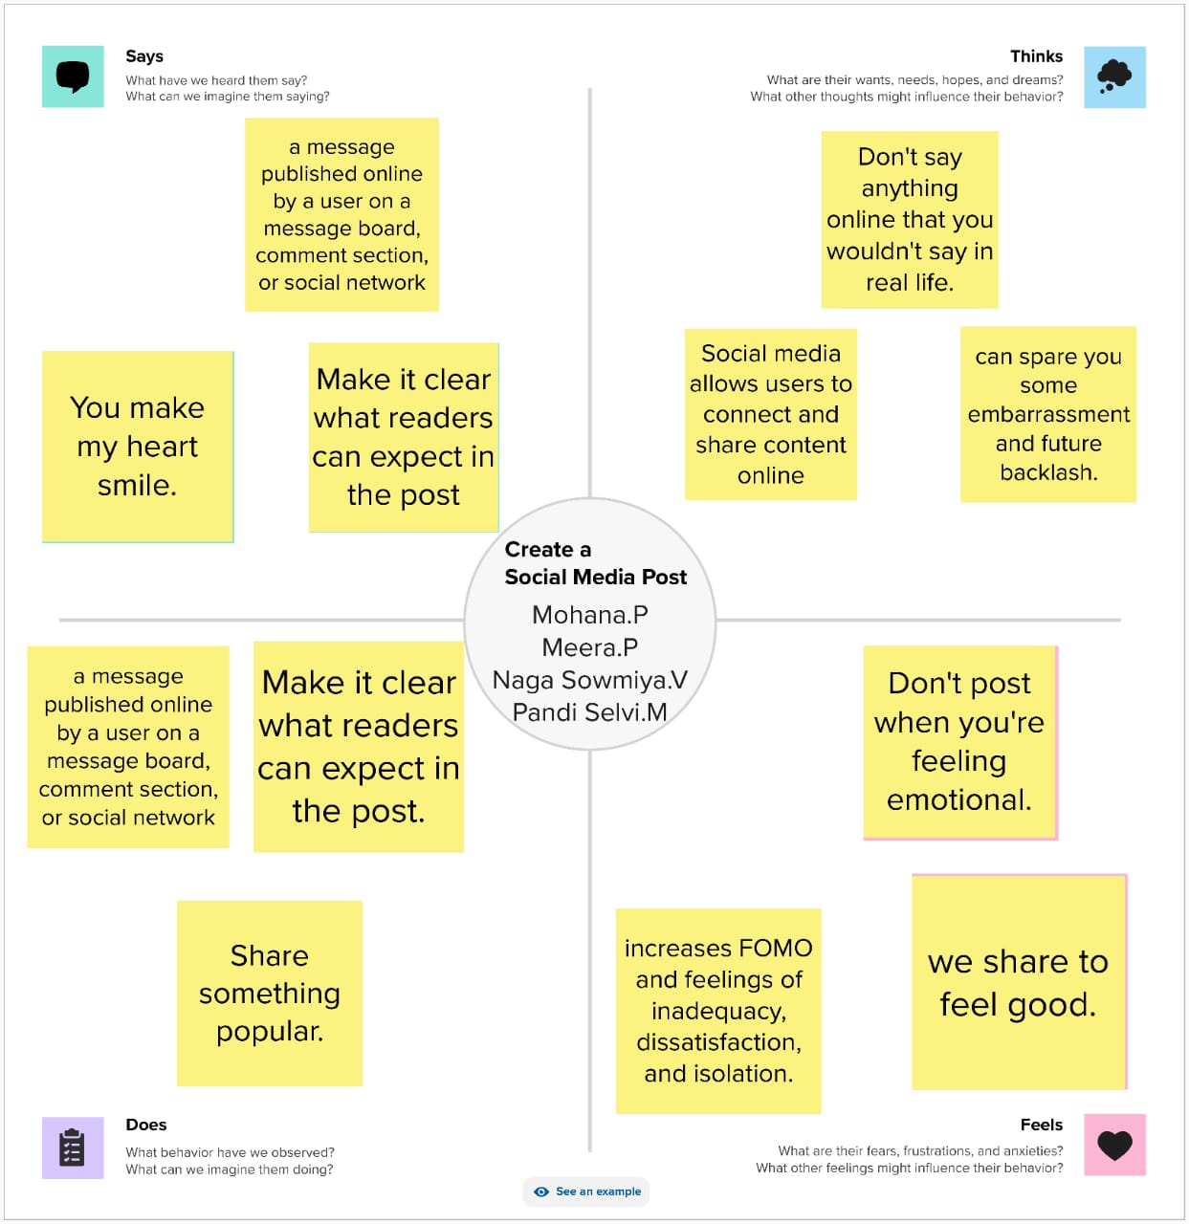
EMPATHY MAP:

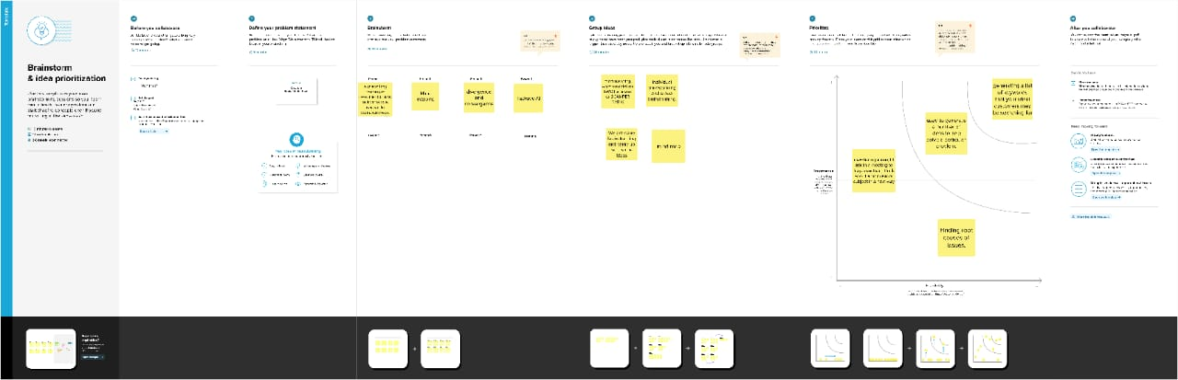
BRAIN STROM :

RESULT



ADVANTAGES & DISADVANTAGE

- It's easy to reach tha people at any time

APPLICATION:
It can gather all people

CONCLUSION:
Successfully

